* **[How to create a task list and add a new task](https://sharepoint.rackspace.com/learning/articles/Pages/SharePoint-2013--how-to-create-a-task-list-and-add-a-new-task.aspx)**

1. From the homepage of your SharePoint site, on the quick launch click **Site Contents**.

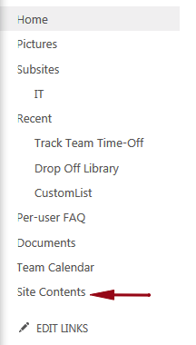

2. Under Lists, Libraries, and other Apps click **add an app**.  
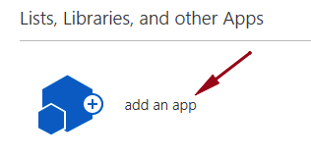

3. Under Noteworthy click **Tasks**.

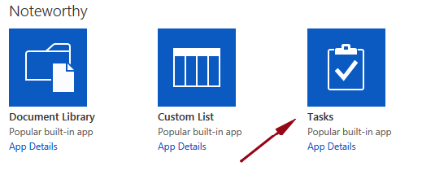

4. In the name section, give it a name, for this example I will call mine “Team Tasks”.

5. Click **Create**.  
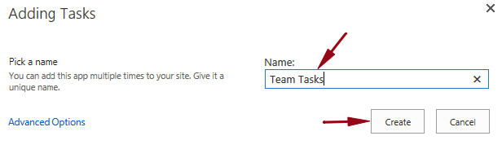

6. Back on the Site Contents page click “**Team Tasks**”  
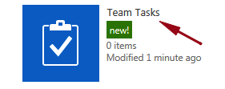

7. Click **+ new task**, to add a new item.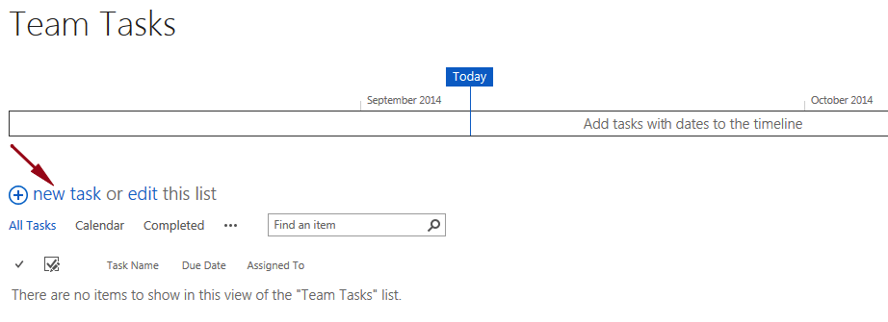

8. Enter the following information:

* 1. Task Name – **First Task**
* 2. Start Date – **9/15/2014** (enter any date you would like)
* 3. Due Date –  **9/19/2014** (enter any date you would like)
* 4. Assigned To – **leave blank**

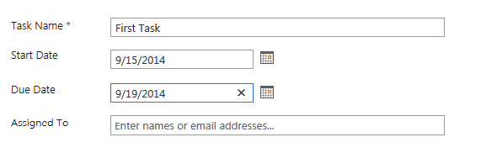

9. Click SHOW MORE.

https://sharepoint.rackspace.com/PublishingImages/Pages/SP2013%20how%20to%20create%20a%20task%20list/createtask8.png

10. Enter the following information:

* % Complete – **50**
* Description –  **This is a test task.**
* Predecessors – **leave blank**
* Priority – **Not Started**

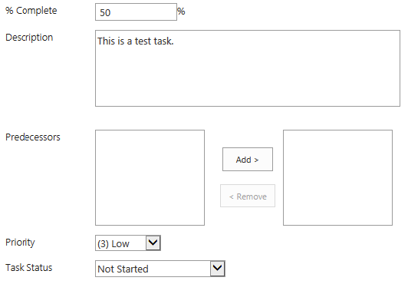

11. Review your task and click **Save**.

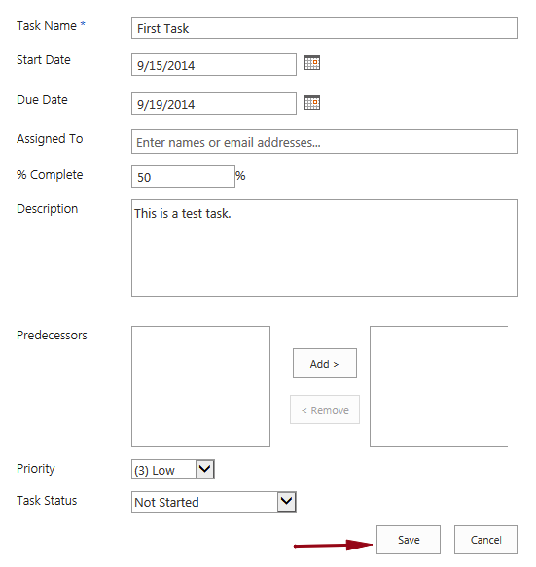

12. You will now see your newly created task.

